**ASBAT EXAMINATIONS BOARD**

**MIDTERM II EXAMINATION 2023**

**Age Group (5 – 6 years): TOP CLASS**

**Learning Area 3: Health Habits**

My name is ______________________________________________

**School: _________________________________________________________**

1. **Fill in the missing letters.**

|  |  |  |
| --- | --- | --- |
| D:\DESKTOP BACKUP\assesst\SAM PICTURES\SAM PICTURES2\animal products\egg 2.jpg | D:\DESKTOP BACKUP\assesst\SAM PICTURES\SAM PICTURES2\fruits\apple 4.png | D:\DESKTOP BACKUP\assesst\SAM PICTURES\SAM PICTURES2\animal outlines\fish2.jpg |
| e____ ____ | a ___ ___le | fis ____ |
|  |  |  |
| mang ____ | y ____m | ma ___ze |

1. **Name these pictures.**

|  |  |  |
| --- | --- | --- |
| D:\DESKTOP BACKUP\assesst\SAM PICTURES\SAM PICTURES2\Human body parts\head.png |  |  |
|  |  |  |
| D:\DESKTOP BACKUP\assesst\SAM PICTURES\SAM PICTURES2\Human body parts\leg.png | https://encrypted-tbn1.gstatic.com/images?q=tbn:ANd9GcQhXhjHgO9g5MaQRR82YXH5l_NQ9B2wpgQvWGJADKIatj9VD7Em0VA_gtc | G:\ \Picture 005.jpg |
|  |  |  |

(leg, head, nose, mouth, eye, ear)

1. **Shade the dangerous objects.**

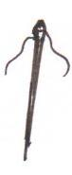

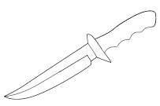

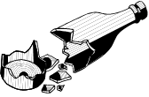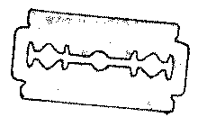

1. **Match pictures to words.**

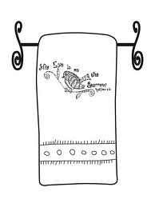

sponge

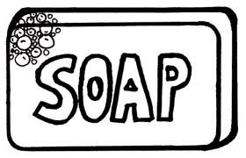

towel

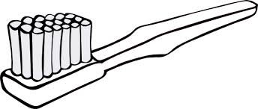

comb



soap

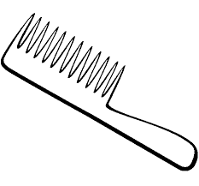

water

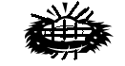

toothbrush

1. **Oral**
2. Who treats sick people?
3. Mention any three fruits we eat.
4. Mention any three things we use when we are bathing.
5. Read the following words.

skirt

leg

water

broom

chalkboard

**END**